Assessing the ‘movescape’ of giant armadillos (*Priodontes maximus*)

**Background**

Studies have been conducted on the habitat selection of giant armadillos in the Brazilian Pantanal, which is useful to determine which patches are most (or least) suitable for resting and foraging by this species. However, the combination of habitat preference with the speed of giant armadillo movements can help to deduce functional connectivity across the landscape. This is similar to the approach taken by Bastille-Rousseau and Wittemyer (2020) where they characterize a ‘movescape’ (or the functional role of areas for movement across a landscape) using a combination of functional and structural connectivity metrics, as well as intrinsic properties of animal behavior from GPS tracks. We approach the estimation of a ‘movescape’ differently by estimating the time spent per pixel (for a given landscape) and compare these estimates against those of habitat selection. By combining the speed of movement with a measure of habitat selection, we can discriminate between potential corridors of connectivity and high risk areas. Additionally, we can also resolve the difference between patches that provide shelter, protection, or quality forage against areas that impede movement.

**Methods**

GPS tracks were available for 7 individuals (blanca, emanuel, gala, mafalda, mazeboti, sara, tex) sampled at 7 min intervals for varying durations from 2019 – 2020.

To estimate habitat selection by these armadillos, I fit a step-selection function (SSF) using land use/land cover (LU/LC) and normalized difference water index (NDWI). SSFs were fit separately by ID. LU/LC included classes for Forest, Open Savanna, Closed Savanna, and Floodable, which reflected the general properties of features across the landscape. NDWI is a metric of water presence that was extracted on a seasonal basis and was included as a way to account for the dynamic change in wet vs dry areas over time. For the SSF, I sampled 30 control points (i.e., available points) for each case point (i.e., used point). The NDWI covariate was extracted from the associated seasonal raster in which the relocation was sampled. A single SSF model was fit to all IDs pooled together and “Forest” was treated as the reference class for LU/LC. Habitat selection surfaces were scaled from 0-1 and estimated for each of the four seasons. If similar, average habitat selection was calculated across seasons.

The velocity-based resistance model was estimated where time spent per pixel is a function of each of the covariates included within the SSF (LU/LC, NDWI). Separate models were fit by ID to assess individual heterogeneity (i.e., differences in functional responses). If there were minimal differences in resistance surfaces for an individual, an average surface was calculated across all seasons. To make a population-level estimate of the movescape, a mean resistance surface and its variance were calculated across all IDs.

Given the estimates of habitat selection and time spent per pixel, the movescape classified pixels as falling into one of four possible categories:

1. Fast-Preferred (e.g., corridors for fast movement)
2. Slow-Preferred (e.g., habitat that is used for resting, foraging, or protection)
3. Fast-Avoided (e.g., easy to move through, but risky/dangerous matrix)
4. Slow-Avoided (e.g., habitat that impedes movement)

These categories will then be mapped onto each pixel of the raster to estimate the movescape of the giant armadillos.

Below, raster layers are shown for the static LU/LC covariate and the dynamic NDWI covariate. Gaps in the Summer raster for NDWI are due to clouds and cloud shadows masked from the Landsat 8 imagery from which this metric was derived.

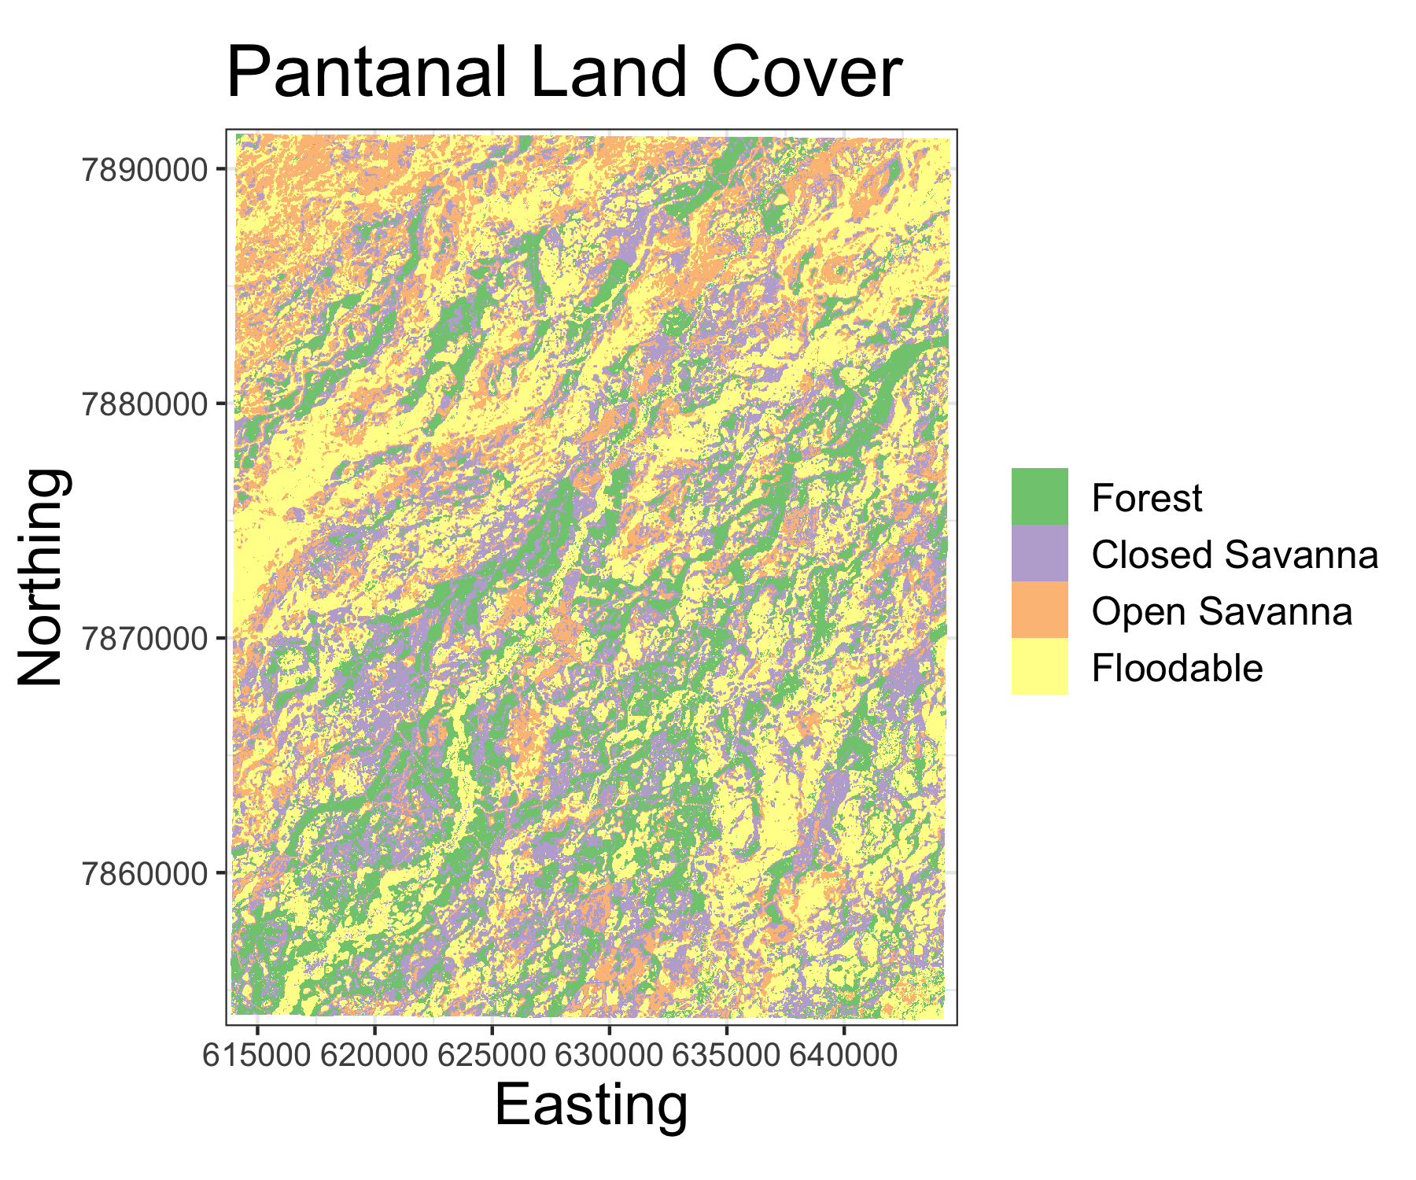

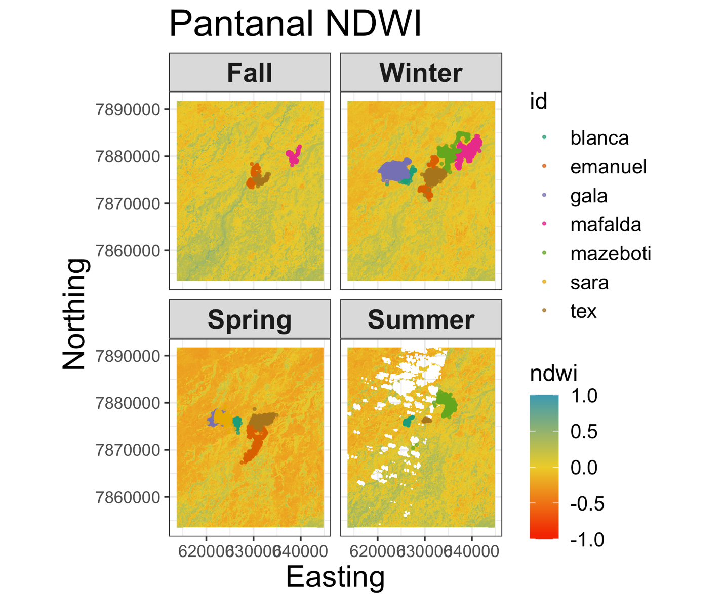

**Results**

The estimated coefficients from the SSF are plotted below and shown on the logit scale from the conditional logistic regression.

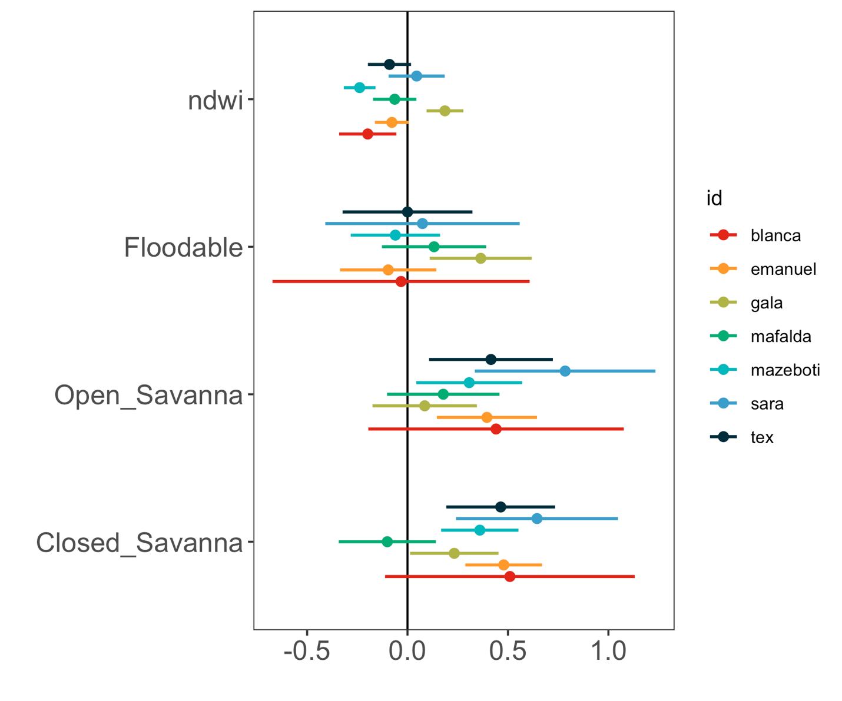

Spatiotemporal predictions of habitat selection are shown on a seasonal basis, but do not exhibit strong differences. Therefore, seasonal predictions were averaged into a single mean layer of habitat selection. These estimates show a strong preference for closed and open savannas and a general avoidance of wet areas (i.e., high NDWI).

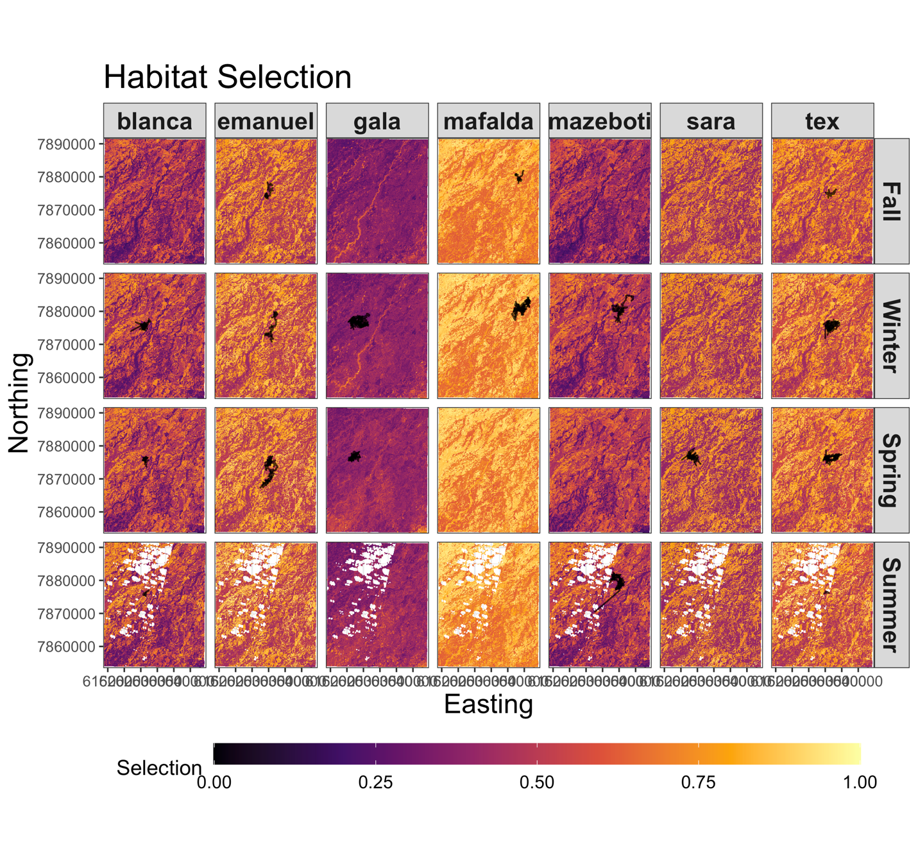

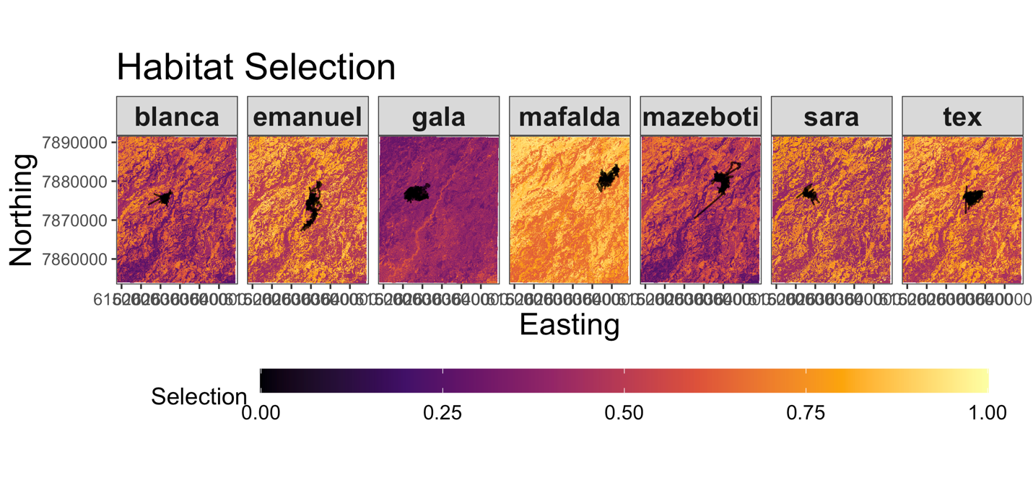

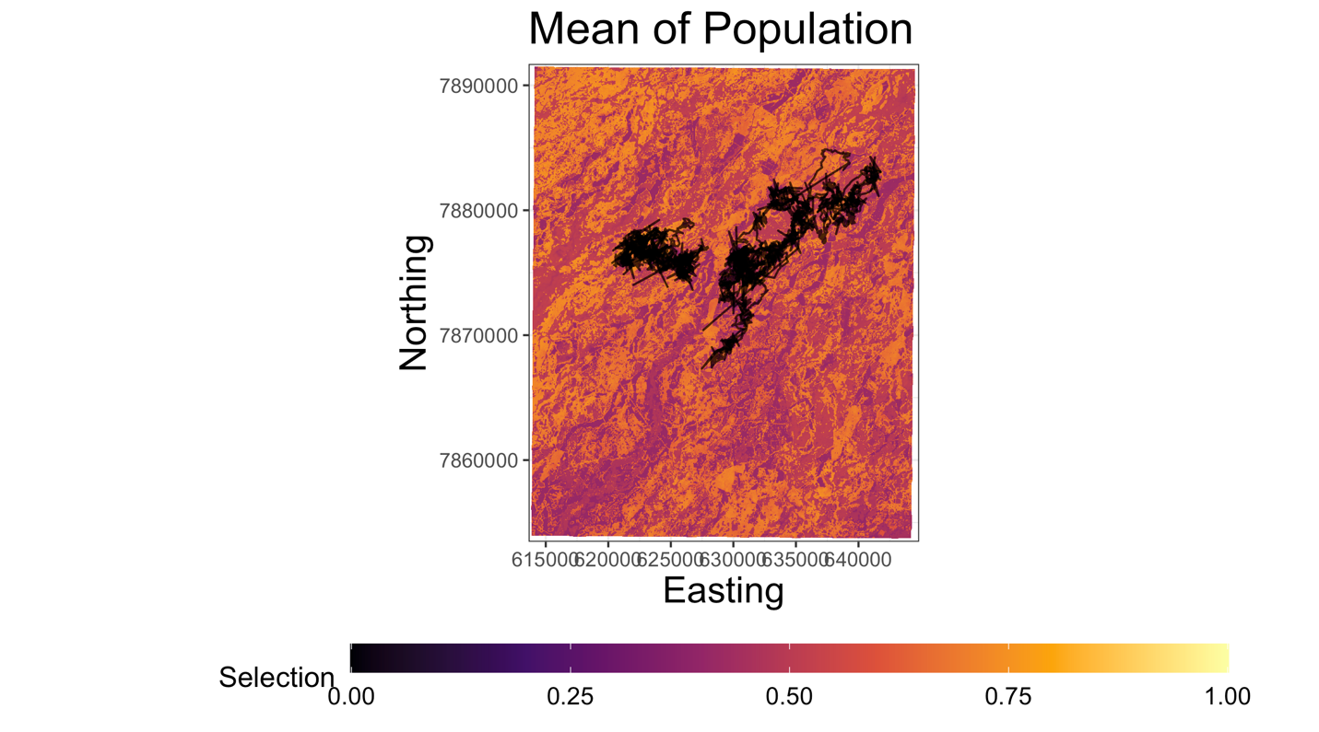

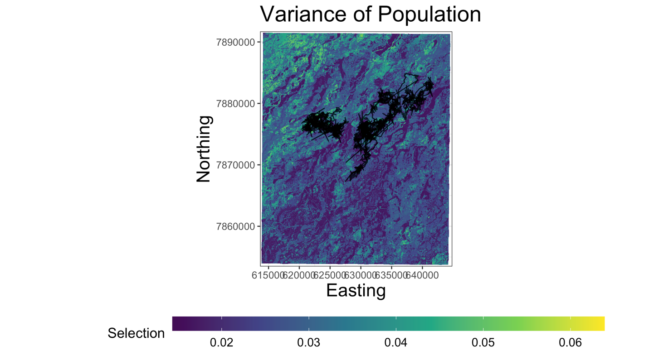

There was a relatively high level of individual heterogeneity in functional responses to each of the environmental covariates. However, the greatest heterogeneity occurred for the estimates of the coefficients for Forest and Floodable land classes. This resulted in spatial estimates of time spent per pixel that varied widely among individuals. However, there was a minimal effect of seasonal impacts since the dynamic variable NDWI had a much lower coefficient than for any of the land classes on average. Therefore, our measures of resistance (i.e., time per pixel) were averaged by ID across seasons. A population mean and variance was calculated across individuals to reduce dimensionality of the data.

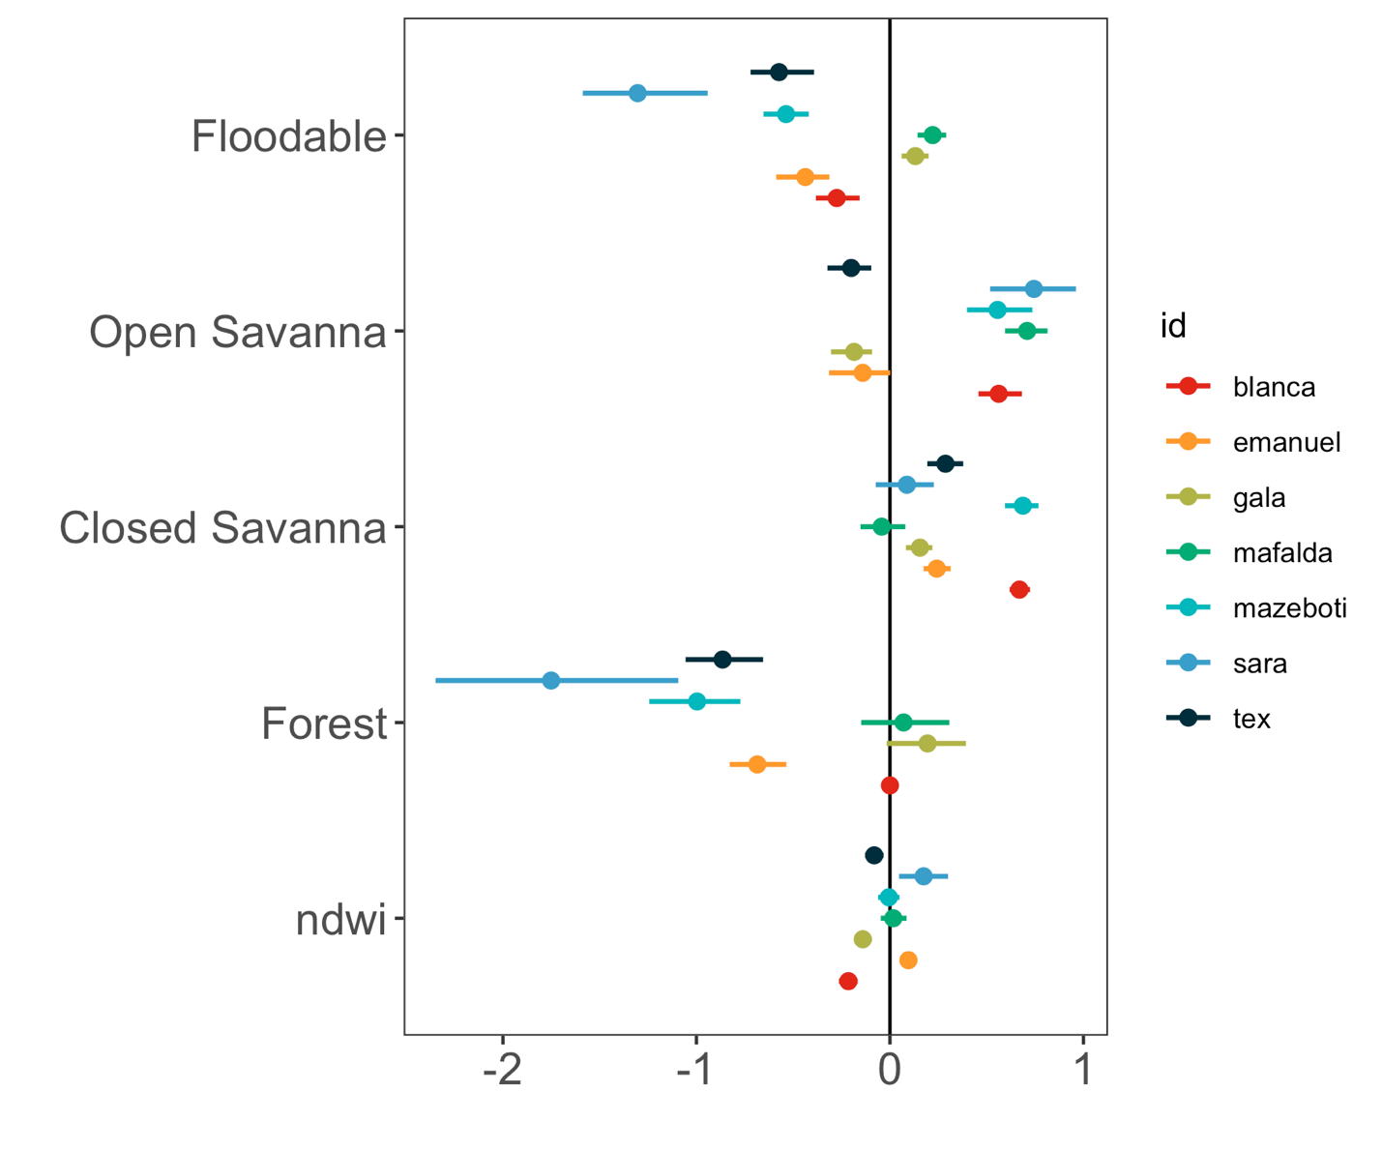

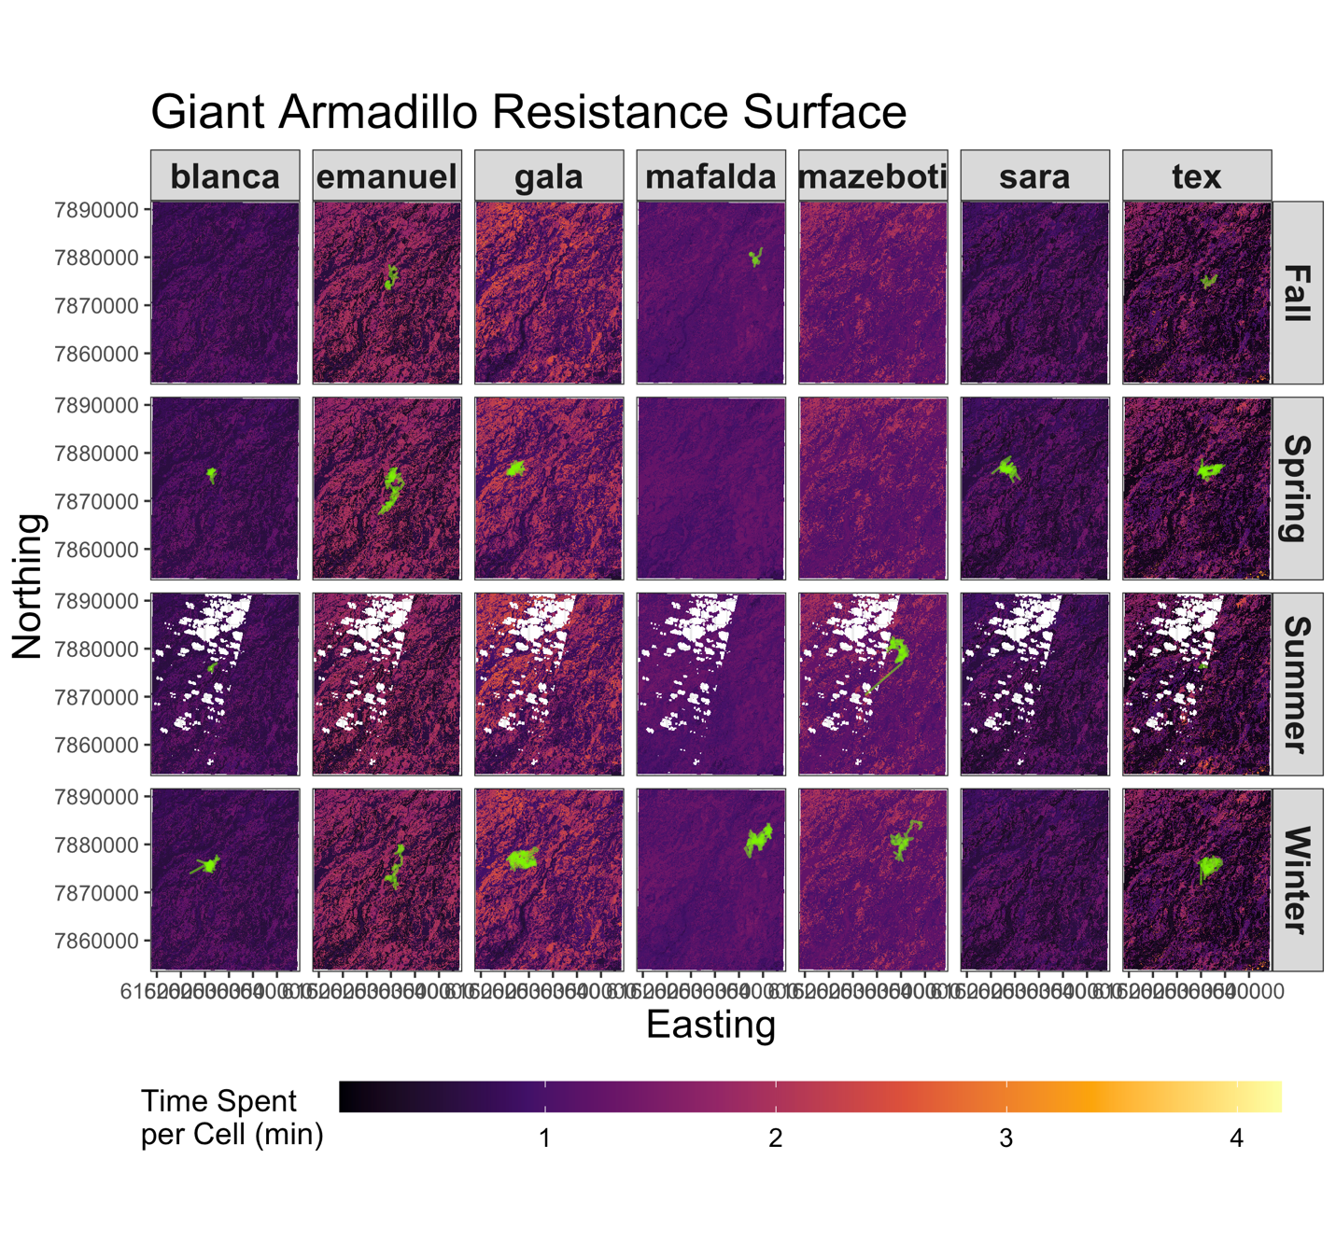

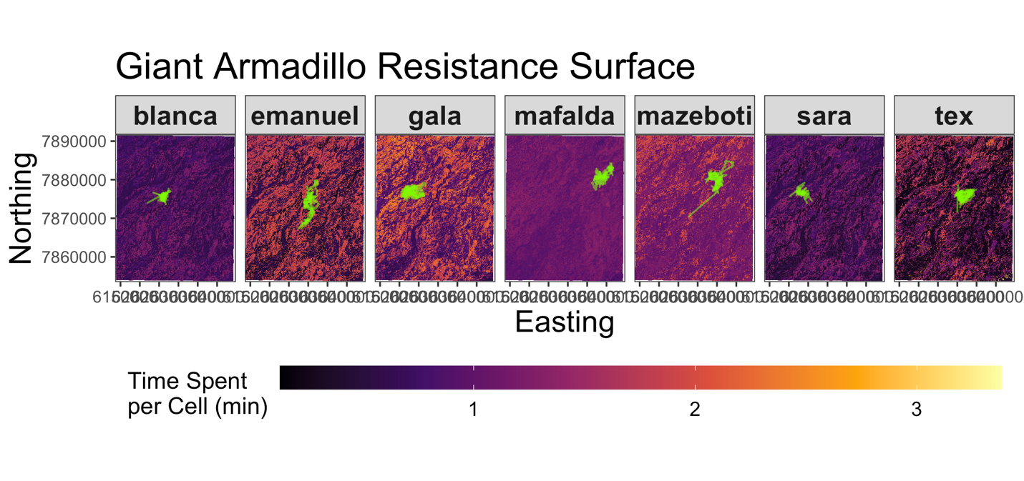

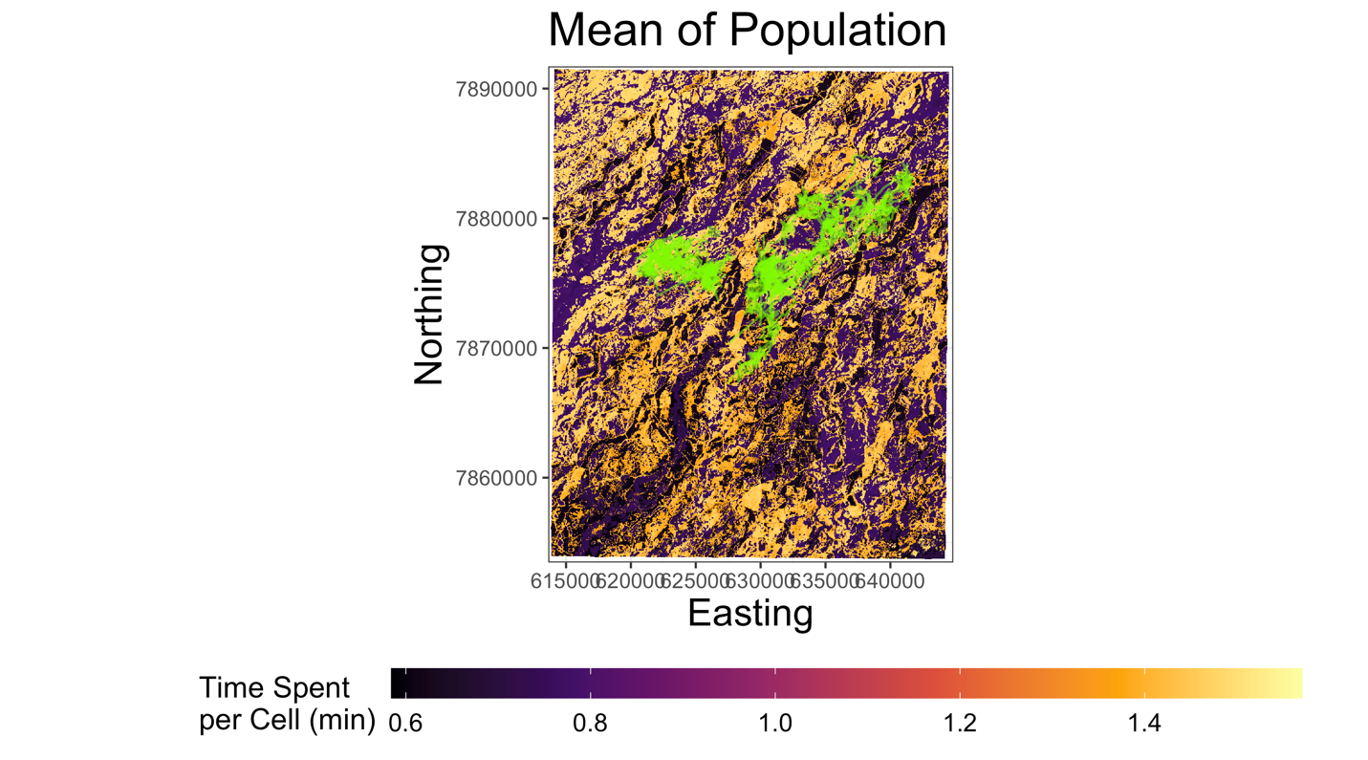

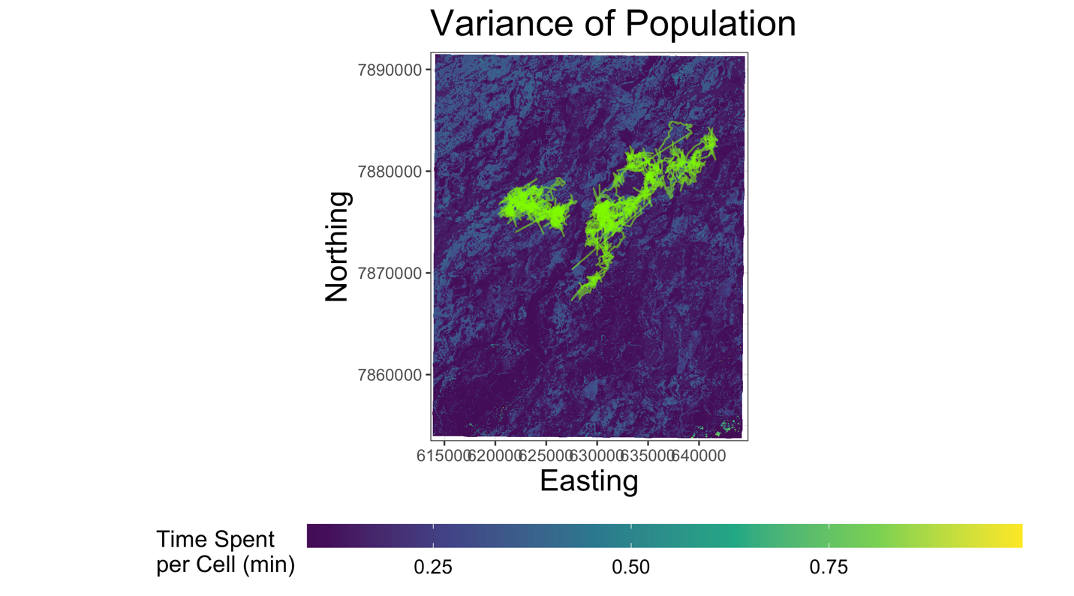

Once estimates of armadillo speed and habitat selection were calculated, these were combined to make inference on the ‘movescape’. Below are plots that compare both sets of estimates and break them into a set of quadrants. These quadrants represent each of the four previously mentioned categories of functional connectivity classifications. Each point represent a single pixel across the study region and they are color-coded by either LU/LC class or by NDWI. From these plots, points (i.e., pixels) are re-classified based on the quadrant in which it falls and then mapped back onto the landscape. Alternatively, they can be plotted using two different monochromatic palettes that can be blended together for a more nuanced interpretation.

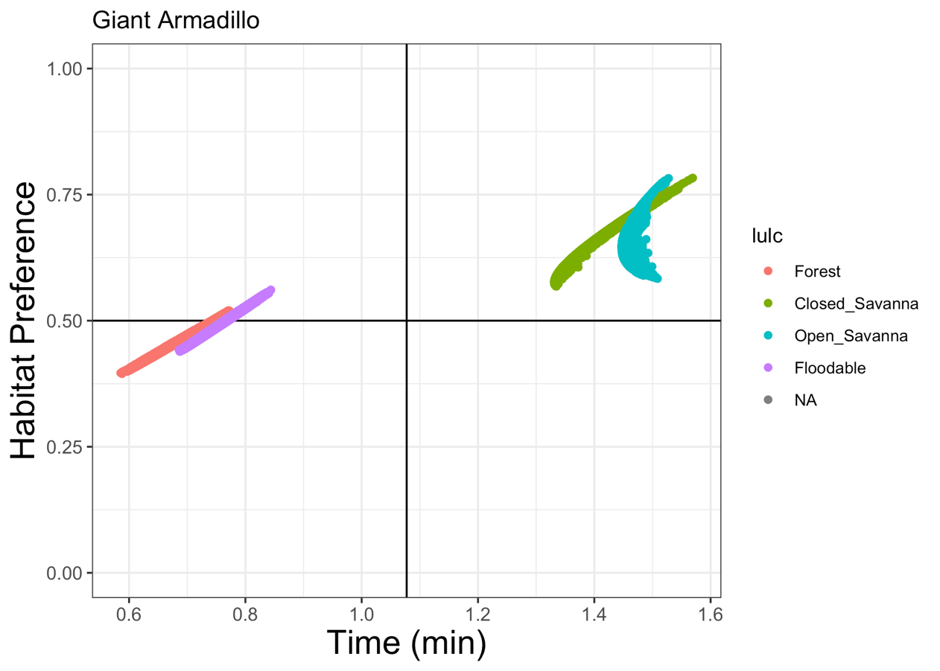

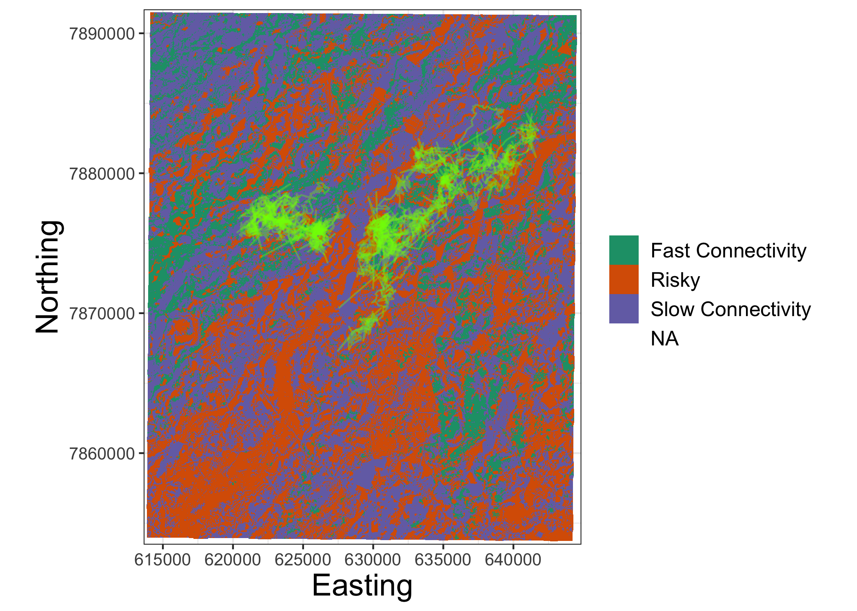

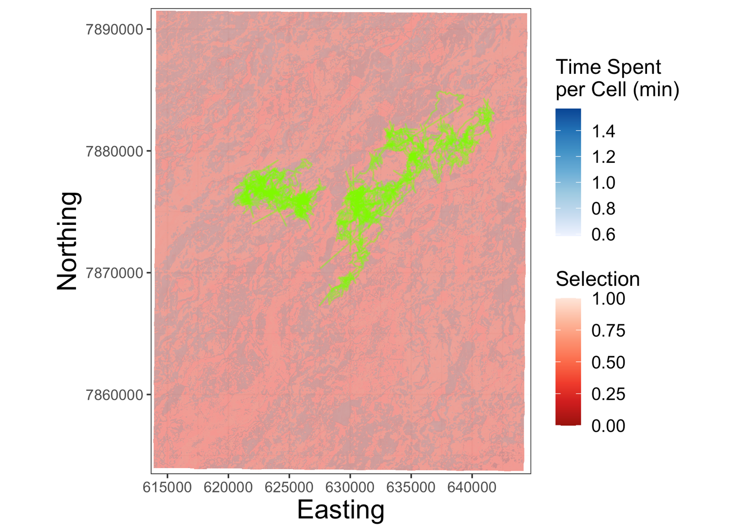

**Discussion**

While these results do appear to provide a simple way to understand movements of giant armadillos, they would likely be improved by making some modifications in the methods to account for the relatively high level of individual heterogeneity when estimating the ‘movescape’ rather than taking a simple average. This may involve fitting separate models for SSFs and resistance per ID and season and using different weighting procedures when integrating estimates to make inference at the population level. Additionally, the inclusion of a greater number of individuals sampled at other locations and seasons throughout the study region is also likely to improve inferences made. The estimates of NDWI could also potentially be improved by using Sentinel-2 satellite imagery to calculate NDWI rather than Landsat 8 since Sentinel-2 captures images at a 10m (vs a 30 m) spatial resolution and at a 5 day (vs a 16 day resolution. This would result in fewer images with cloud cover that could be used to calculate seasonal band values, which would likely fill in the gaps in the estimates of summer NDWI. These steps and others (e.g., multi-spatial scale analyses) can be taken to improve these results to estimate dynamic landscape connectivity in giant armadillos.